## Persistence – Exam Preparation Question

**General part**

* Describe how we have handled persistence in the last three semesters. The considerations should include all relevant layers. File IO, Relational Databases, the browsers local storage and cookies on the browser.
* Explain the Pros & Cons in using an Object Relational Mapping Framework
* Elaborate on some of the problems a ORM tries to solve
* Explain how Inheritance in an OO language can be mapped to tables in a relational database

**Practical part**

We need a data model for the following domain:

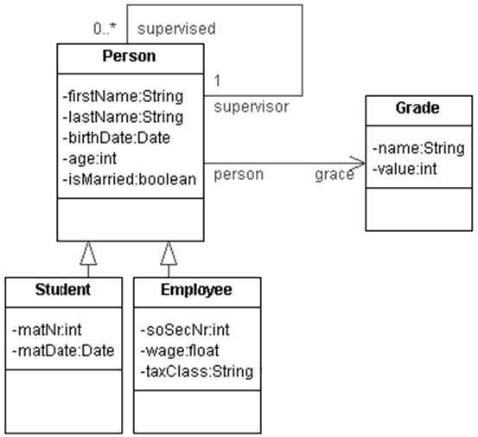

Implement a JPA solution which should implement the design given above:

1. You must present both the JPA entity classes and the corresponding tables. You decide whether you want to create the tables first and then the Entity classes or the other way around.
2. It's up to you to decide which Inheritance Strategy to use, but you must argue for your choice.
3. Make a small façade which should make it possible to:

* **add, edit, find** and **delete** Persons, Students, Employees and PhDStudients
* Provide necessary getters and setters to the Person hierarchy so all information is available, for example who is a Persons supervisor and the list of who a Person supervises.

1. If you have time. Provide a small rest API that, using the façade, manipulates the database